

Session: 2020-2021

MINI PROJECT REPORT
On
“ To Do List”

BACHELOR OF TECHNOLOGY IN COMPUTER
SCIENCE AND ENGINEERING

Submitted to-
Mr. Pratik Shrivastva
(Department of Computer Science & Engineering)

Submitted by-
Abhinav Singwal

Roll No. : Lateral Entry

3
RD
SEMESTER
DEPARTMENT OF COMPUTER
SCIENCE AND ENGINEERING/IT/EC/EE/BT/ME
MEERUT INSTITUTE OF ENGINEERING AND TECHNOLOGY, MEERUT

DECLARATION

We hereby declare that the project entitled -“To Do List”, which is being submitted as Mini
Project in department of Computer Science and engineering to Meerut Institute of Engineering
and Technology, Meerut (U.P.) is an authentic record of our genuine work done under the
guidance of Prof. “Mr. Pratik Shrivastva” of Computer Science and Engineering, Meerut Institute
of Engineering and Technology, Meerut.

Date:

Abhinav Singwal
Place:

Lateral Entry

CERTIFICATE

This is to certify that mini project report entitled – “To Do List” submitted by “Abhinav Singwal”
has been carried out under the guidance of Prof. “Pratik Shrivastva” of Computer Science
and Engineering, Meerut Institute of Engineering and Technology, Meerut. This project report is
approved for Mini Project (KCN 354) in 3
rd
semester in “department name” from Meerut
Institute of Engineering and Technology, Meerut.

Internal Examiner
Date:
.

ACKNOWLEDGEMENT

I express my sincere indebtedness towards our guide Prof., “Pratik Shrivastva” of Computer
Science and Engineering, Meerut Institute of Engineering and Technology, Meerut for his
valuable suggestion, guidance and supervision throughout the work. Without his king patronage
and guidance the project would not have taken shape. I would also like to express my gratitude
and sincere regards for his kind approval of the project. Time to time counseling and advises.
I would also like to thank to our HoD Dr. (Prof.) “Nidhi Choudhary”, Department of Computer Science
and engineering, Meerut Institute of Engineering and Technology, Meerut for his expert advice
and counseling from time to time.
I owe sincere thanks to all the faculty members in the department of Computer Science and
engineering for their kind guidance and encouragement time to time.

Date:

Abhinav Singwal

Table of contents

Description

page no.

Declaration

i

Certificate

ii

Acknowledgement

iii
Chapter 1

Introduction

Chapter 2

System Design
(Work flow/flow chart/DFD/ working principle/ constructional
details of individual componenets)
Chapter 3

Technology Bucket

3.1 Description of HTML

3.3 Description of CSS

3.4 Description of Java Script
Chapter 4

Output screens
Appendices

Implementation code
References

Introduction

ToDoList is software in the category of Task Management, Project Management, Productivity, “Getting Things Done” (GTD), Scheduling, and Collaboration.
We have a lot of choices to help us keep track of daily obligations. A simple list on paper of things “To Do” is enough for some people. Others prefer to use programs. People have preferences about where they keep track of tasks - with PC utilities (“thick app”), websites (“thin app”), on phone (“mobile”) apps. Some software is very general, with nothing more than a simple list of task names and due dates. Some get more sophisticated with nested tasks, where you need to complete the nested tasks in order to consider the main task complete. Some commercial software is Very sophisticated, and costs a lot - look at Microsoft Project and similar offerings. Some software is focused on specific industries, for construction, manufacturing, business consulting, website management, wedding planning, or even cooking recipes.

ToDoList (often abbreviated TDL) was created by .dan.g. in 2003 for his own personal use. He published the software as Free and Open Source and to this day he continues to maintain the software for himself and for the large number of people who use it. Dan's “model” is that he gets feedback from the field in the form of bugs, enhancement suggestions, and general comments, and then he incorporates the feedback into the software. He has worked fairly continuously on the software for the single reason that it brings him joy. If it ever stops bringing him joy he will probably stop working on it.

System Design

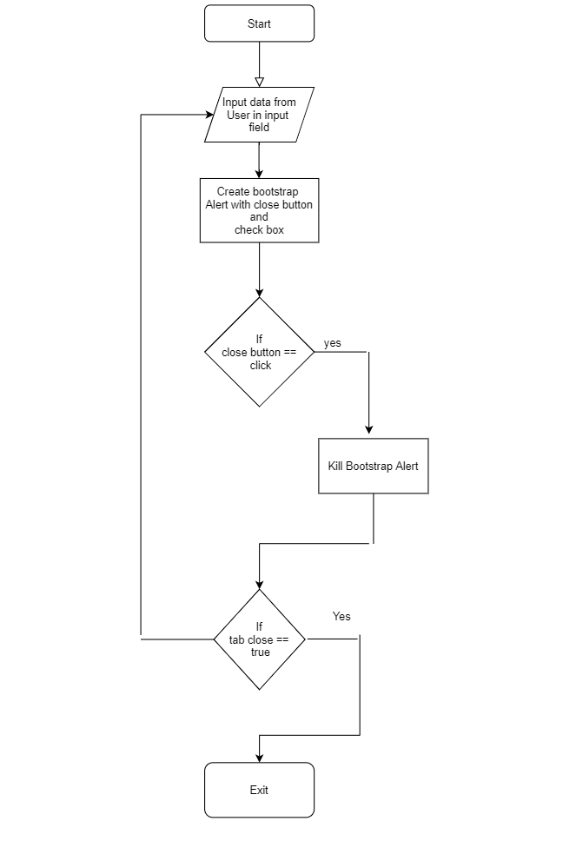

Technology Bucket

1. Description of HTML

Hypertext Markup Language (HTML) is the standard markup language for documents designed to be displayed in a web browser. It can be assisted by technologies such as Cascading Style Sheets (CSS) and scripting languages such as JavaScript.

Web browsers receive HTML documents from a web server or from local storage and render the documents into multimedia web pages. HTML describes the structure of a web page semantically and originally included cues for the appearance of the document.

HTML elements are the building blocks of HTML pages. With HTML constructs, images and other objects such as interactive forms may be embedded into the rendered page. HTML provides a means to create structured documents by denoting structural semantics for text such as headings, paragraphs, lists, links, quotes and other items. HTML elements are delineated by tags, written using angle brackets. Tags such as <img /> and <input /> directly introduce content into the page. Other tags such as <p> surround and provide information about document text and may include other tags as sub-elements. Browsers do not display the HTML tags, but use them to interpret the content of the page.

HTML can embed programs written in a scripting language such as JavaScript, which affects the behavior and content of web pages. Inclusion of CSS defines the look and layout of content. The World Wide Web Consortium (W3C), former maintainer of the HTML and current maintainer of the CSS standards, has encouraged the use of CSS over explicit presentational HTML since 1997.[2]

In 1980, physicist Tim Berners-Lee, a contractor at CERN, proposed and prototyped ENQUIRE, a system for CERN researchers to use and share documents. In 1989, Berners-Lee wrote a memo proposing an Internet-based hypertext system.[3] Berners-Lee specified HTML and wrote the browser and server software in late 1990. That year, Berners-Lee and CERN data systems engineer Robert Cailliau collaborated on a joint request for funding, but the project was not formally adopted by CERN. In his personal notes[4] from 1990 he listed[5] "some of the many areas in which hypertext is used" and put an encyclopedia first.

The first publicly available description of HTML was a document called "HTML Tags", first mentioned on the Internet by Tim Berners-Lee in late 1991.[6][7] It describes 18 elements comprising the initial, relatively simple design of HTML. Except for the hyperlink tag, these were strongly influenced by SGMLguid, an in-house Standard Generalized Markup Language (SGML)-based documentation format at CERN. Eleven of these elements still exist in HTML 4.[8]

HTML is a markup language that web browsers use to interpret and compose text, images, and other material into visual or audible web pages. Default characteristics for every item of HTML markup are defined in the browser, and these characteristics can be altered or enhanced by the web page designer's additional use of CSS. Many of the text elements are found in the 1988 ISO technical report TR 9537 Techniques for using SGML, which in turn covers the features of early text formatting languages such as that used by the RUNOFF command developed in the early 1960s for the CTSS (Compatible Time-Sharing System) operating system: these formatting commands were derived from the commands used by typesetters to manually format documents. However, the SGML concept of generalized markup is based on elements (nested annotated ranges with attributes) rather than merely print effects, with also the separation of structure and markup; HTML has been progressively moved in this direction with CSS.

Berners-Lee considered HTML to be an application of SGML. It was formally defined as such by the Internet Engineering Task Force (IETF) with the mid-1993 publication of the first proposal for an HTML specification, the "Hypertext Markup Language (HTML)" Internet Draft by Berners-Lee and Dan Connolly, which included an SGML Document type definition to define the grammar.[9][10] The draft expired after six months, but was notable for its acknowledgment of the NCSA Mosaic browser's custom tag for embedding in-line images, reflecting the IETF's philosophy of basing standards on successful prototypes. Similarly, Dave Raggett's competing Internet-Draft, "HTML+ (Hypertext Markup Format)", from late 1993, suggested standardizing already-implemented features like tables and fill-out forms.[11]

After the HTML and HTML+ drafts expired in early 1994, the IETF created an HTML Working Group, which in 1995 completed "HTML 2.0", the first HTML specification intended to be treated as a standard against which future implementations should be based.[12]

Further development under the auspices of the IETF was stalled by competing interests. Since 1996, the HTML specifications have been maintained, with input from commercial software vendors, by the World Wide Web Consortium (W3C).[13] However, in 2000, HTML also became an international standard (ISO/IEC 15445:2000). HTML 4.01 was published in late 1999, with further errata published through 2001. In 2004, development began on HTML5 in the Web Hypertext Application Technology Working Group (WHATWG), which became a joint deliverable with the W3C in 2008, and completed and standardized on 28 October 2014.[14]

HTML versions timeline
HTML 2
November 24, 1995
HTML 2.0 was published as RFC 1866. Supplemental RFCs added capabilities:
November 25, 1995: RFC 1867 (form-based file upload)
May 1996: RFC 1942 (tables)
August 1996: RFC 1980 (client-side image maps)
January 1997: RFC 2070 (internationalization)
HTML 3
January 14, 1997
HTML 3.2[15] was published as a W3C Recommendation. It was the first version developed and standardized exclusively by the W3C, as the IETF had closed its HTML Working Group on September 12, 1996.[16]
Initially code-named "Wilbur",[17] HTML 3.2 dropped math formulas entirely, reconciled overlap among various proprietary extensions and adopted most of Netscape's visual markup tags. Netscape's blink element and Microsoft's marquee element were omitted due to a mutual agreement between the two companies.[13] A markup for mathematical formulas similar to that in HTML was not standardized until 14 months later in MathML.
HTML 4
December 18, 1997
HTML 4.0[18] was published as a W3C Recommendation. It offers three variations:
Strict, in which deprecated elements are forbidden
Transitional, in which deprecated elements are allowed
Frameset, in which mostly only frame related elements are allowed.
Initially code-named "Cougar",[17] HTML 4.0 adopted many browser-specific element types and attributes, but at the same time sought to phase out Netscape's visual markup features by marking them as deprecated in favor of style sheets. HTML 4 is an SGML application conforming to ISO 8879 – SGML.[19]
April 24, 1998
HTML 4.0[20] was reissued with minor edits without incrementing the version number.
December 24, 1999
HTML 4.01[21] was published as a W3C Recommendation. It offers the same three variations as HTML 4.0 and its last errata were published on May 12, 2001.
May 2000
ISO/IEC 15445:2000[22][23] ("ISO HTML", based on HTML 4.01 Strict) was published as an ISO/IEC international standard. In the ISO this standard falls in the domain of the ISO/IEC JTC1/SC34 (ISO/IEC Joint Technical Committee 1, Subcommittee 34 – Document description and processing languages).[22]
After HTML 4.01, there was no new version of HTML for many years as development of the parallel, XML-based language XHTML occupied the W3C's HTML Working Group through the early and mid-2000s.
HTML 5
Main article: HTML5
October 28, 2014
HTML5[24] was published as a W3C Recommendation.[25]
November 1, 2016
HTML 5.1[26] was published as a W3C Recommendation.[27][28]
December 14, 2017
HTML 5.2[29] was published as a W3C Recommendation.[30][31]

2. Description of CSS

Cascading Style Sheets (CSS) is a style sheet language used for describing the presentation of a document written in a markup language such as HTML.[1] CSS is a cornerstone technology of the World Wide Web, alongside HTML and JavaScript.[2]

CSS is designed to enable the separation of presentation and content, including layout, colors, and fonts.[3] This separation can improve content accessibility, provide more flexibility and control in the specification of presentation characteristics, enable multiple web pages to share formatting by specifying the relevant CSS in a separate .css file which reduces complexity and repetition in the structural content as well as enabling the .css file to be cached to improve the page load speed between the pages that share the file and its formatting.

Separation of formatting and content also makes it feasible to present the same markup page in different styles for different rendering methods, such as on-screen, in print, by voice (via speech-based browser or screen reader), and on Braille-based tactile devices. CSS also has rules for alternate formatting if the content is accessed on a mobile device.[4]

The name cascading comes from the specified priority scheme to determine which style rule applies if more than one rule matches a particular element. This cascading priority scheme is predictable.

The CSS specifications are maintained by the World Wide Web Consortium (W3C). Internet media type (MIME type) text/css is registered for use with CSS by RFC 2318 (March 1998). The W3C operates a free CSS validation service for CSS documents.[5]

In addition to HTML, other markup languages support the use of CSS including XHTML, plain XML, SVG, and XUL.

3. Description of JavaScript

The Mosaic web browser was released in 1993. As the first browser with a graphical user interface accessible to non-technical people, it played a prominent role in the rapid growth of the nascent World Wide Web.[10] The lead developers of Mosaic then founded the Netscape corporation, which released a more polished browser, Netscape Navigator, in 1994. Navigator quickly became the most used browser.[11]

During these formative years of the Web, web pages could only be static, lacking the capability for dynamic behavior after the page was loaded in the browser. There was a desire in the burgeoning web development scene to remove this limitation, so in 1995, Netscape decided to add a scripting language to Navigator. They pursued two routes to achieve this: collaborating with Sun Microsystems to embed the Java programming language, while also hiring Brendan Eich to embed the Scheme language.[12]

Netscape management soon decided that the best option was for Eich to devise a new language, with syntax similar to Java and less like Scheme or other extant scripting languages.[12] Although the new language and its interpreter implementation were officially called LiveScript when first shipped as part of a Navigator release in September 1995, the name was changed to JavaScript three months later.[12][1][13]

The choice of the JavaScript name has caused confusion, sometimes giving the impression that it is a spin-off of Java. Since Java was the hot new programming language at the time, this has been characterized as a marketing ploy by Netscape to give its own new language cachet.[14]

Adoption by Microsoft
Microsoft debuted Internet Explorer in 1995, leading to a browser war with Netscape. On the JavaScript front, Microsoft reverse-engineered the Navigator interpreter to create its own, called JScript.

JScript was first released in 1996, alongside initial support for CSS and extensions to HTML. Each of these implementations was noticeably different from their counterparts in Navigator.[15][16] These differences made it difficult for developers to make their websites work well in both browsers, leading to widespread use of "best viewed in Netscape" and "best viewed in Internet Explorer" logos for several years.[15][17]

The rise of JScript
In November 1996, Netscape submitted JavaScript to ECMA International, as the starting point for a standard specification that all browser vendors could conform to. This led to the official release of the first ECMAScript language specification in June 1997.

The standards process continued for a few years, with the release of ECMAScript 2 in June 1998 and ECMAScript 3 in December 1999. Work on ECMAScript 4 began in 2000.

Meanwhile, Microsoft gained an increasingly dominant position in the browser market. By the early 2000s, Internet Explorer's market share reached 95%.[18] This meant that JScript became the de facto standard for client-side scripting on the Web.

Microsoft initially participated in the standards process and implemented some proposals in its JScript language, but eventually it stopped collaborating on ECMA work. Thus ECMAScript 4 was mothballed.

Growth and standardization
During the period of Internet Explorer dominance in the early 2000s, client-side scripting was stagnant. This started to change in 2004, when the successor of Netscape, Mozilla, released the Firefox browser. Firefox was well-received by many, taking significant market share from Internet Explorer.[19]

In 2005, Mozilla joined ECMA International, and work started on the ECMAScript for XML (E4X) standard. This led to Mozilla working jointly with Macromedia (later acquired by Adobe Systems), who were implementing E4X in their ActionScript 3 language, which was based on an ECMAScript 4 draft. The goal became standardizing ActionScript 3 as the new ECMAScript 4. To this end, Adobe Systems released the Tamarin implementation as an open source project. However, Tamarin and ActionScript 3 were too different from established client-side scripting, and without cooperation from Microsoft, ECMAScript 4 never reached fruition.

Meanwhile, very important developments were occurring in open source communities not affiliated with ECMA work. In 2005, Jesse James Garrett released a white paper in which he coined the term Ajax and described a set of technologies, of which JavaScript was the backbone, to create web applications where data can be loaded in the background, avoiding the need for full page reloads. This sparked a renaissance period of JavaScript, spearheaded by open source libraries and the communities that formed around them. Many new libraries were created, including jQuery, Prototype, Dojo Toolkit, and MooTools.

Google debuted its Chrome browser in 2008, with the V8 JavaScript engine that was faster than its competition.[20][21] The key innovation was just-in-time compilation (JIT),[22] so other browser vendors needed to overhaul their engines for JIT.[23]

In July 2008, these disparate parties came together for a conference in Oslo. This led to the eventual agreement in early 2009 to combine all relevant work and drive the language forward. The result was the ECMAScript 5 standard, released in December 2009.

Reaching maturity
Ambitious work on the language continued for several years, culminating in an extensive collection of additions and refinements being formalized with the publication of ECMAScript 6 in 2015.[24]

From 2016 to 2019, a new version of the ECMAScript standard was published each year, but the scope of changes was much smaller than the 5th or 6th editions. Thus JavaScript can now be considered a mature language that has largely settled down.

The current JavaScript ecosystem has many libraries and frameworks, established programming practices, and increased usage of JavaScript outside of web browsers. Plus, with the rise of single-page applications and other JavaScript-heavy websites, a number of transpilers have been created to aid the development process.[25]

Trademark
"JavaScript" is a trademark of Oracle Corporation in the United States.[26] It is used under license for technology invented and implemented by Netscape Communications and other parties.[27]

Website client-side usage
JavaScript is the dominant client-side scripting language of the Web, with 95% of websites using it for this purpose.[9] Scripts are embedded in or included from HTML documents and interact with the DOM. All major web browsers have a built-in JavaScript engine that executes the code on the user's device.

Examples of scripted behavior
See also: Dynamic HTML and Ajax (programming)
Loading new page content without reloading the page. For example, social media websites use Ajax so that users can post new messages without leaving the page.
Animation of page elements, such as fading them in and out, resizing, and moving them.
Interactive content, such as games and video.
Validating input values of a web form to make sure that they are acceptable before being submitted to the server.
Transmitting information about the user's behavior for analytics, ad tracking, and personalization.
Libraries and frameworks
The majority of websites use a third-party JavaScript library or web application framework as part of their client-side page scripting.[28]

jQuery is the most popular library, used by over 70% of websites.[28]

The Angular framework was created by Google for its web services; it is now open source and used by other websites. Likewise, Facebook created the React framework for its website and later released it as open source; other sites, including Twitter, now use it. There are other open source frameworks in use, such as Backbone.js and Vue.js.[28]

In contrast, the term "Vanilla JS" has been coined for websites not using any libraries or frameworks, instead relying entirely on standard JavaScript functionality.[29]

Other usage
The use of JavaScript has expanded beyond its web browser roots. JavaScript engines are now embedded in a variety of other software systems, both for server-side website deployments and non-browser applications.

Initial attempts at promoting server-side JavaScript usage were Netscape Enterprise Server and Microsoft's Internet Information Services,[30][31] but they were small niches.[32] Server-side usage eventually started to grow in the late-2000s, with the creation of Node.js and other approaches.[32]

Electron, Cordova, and other software frameworks have been used to create many applications with behavior implemented in JavaScript. Other non-browser applications include Adobe Acrobat support for scripting PDF documents[33] and GNOME Shell extensions written in JavaScript.[34]

JavaScript has recently begun to appear in some embedded systems, usually by leveraging Node.js.[35][36][37]

Features
The following features are common to all conforming ECMAScript implementations, unless explicitly specified otherwise.

Imperative and structured
JavaScript supports much of the structured programming syntax from C (e.g., if statements, while loops, switch statements, do while loops, etc.). One partial exception is scoping: JavaScript originally had only function scoping with var. ECMAScript 2015 added keywords let and const for block scoping, meaning JavaScript now has both function and block scoping. Like C, JavaScript makes a distinction between expressions and statements. One syntactic difference from C is automatic semicolon insertion, which allows the semicolons that would normally terminate statements to be omitted.[38]

Output Screens

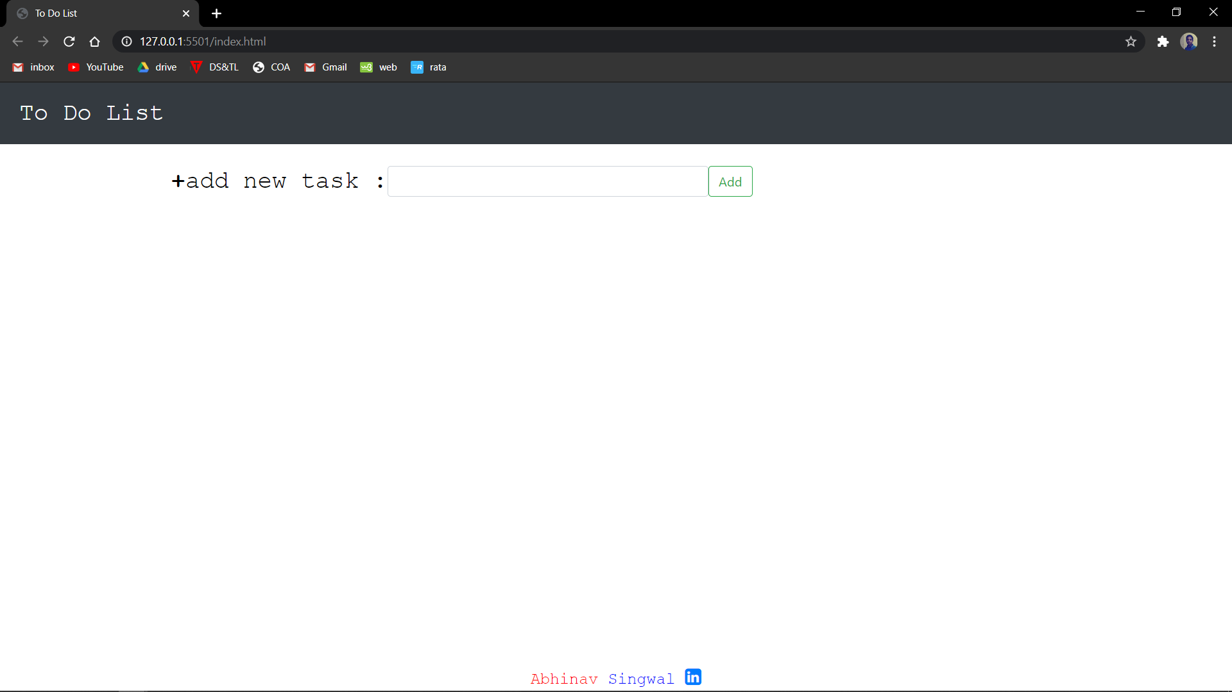
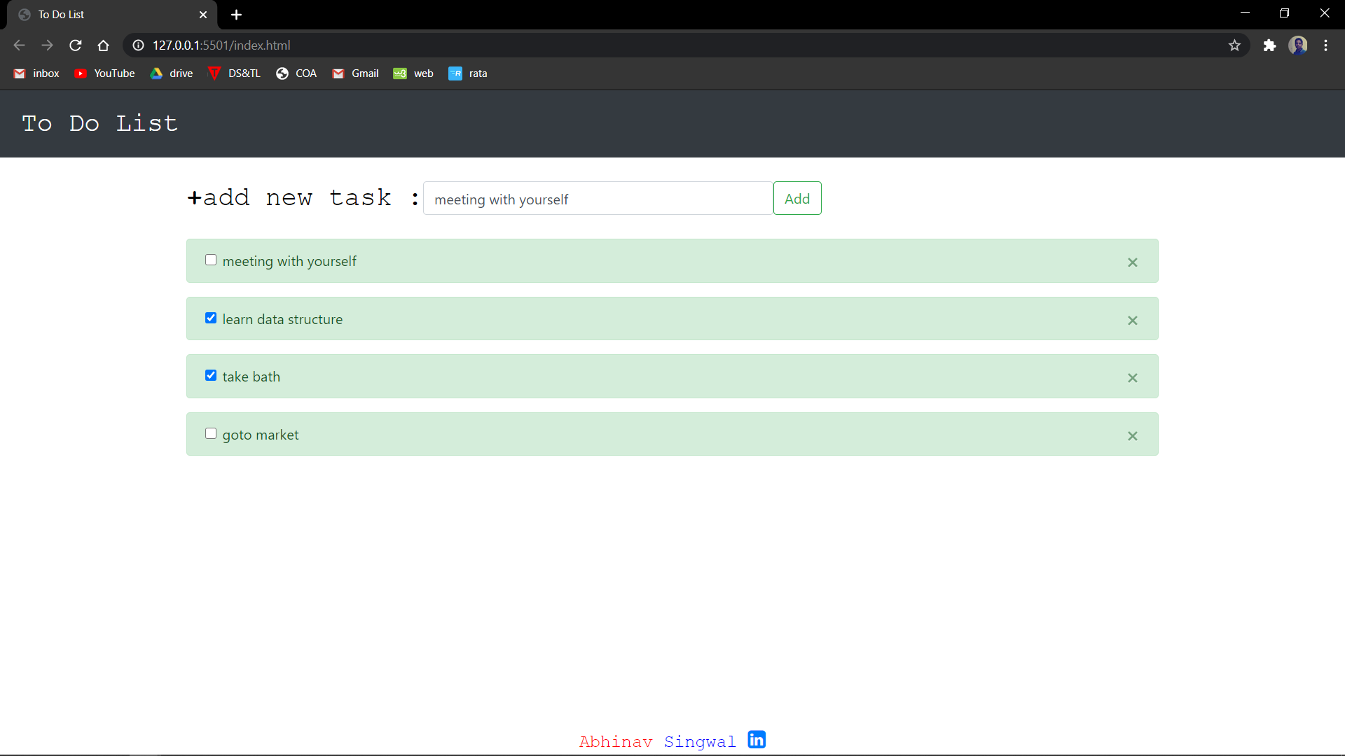

Appendices

index.html

<!DOCTYPE html>
<html lang="en">
<head>
<meta http-equiv="Content-Type" content="text/html; charset=utf-8" />
<title>To Do List</title>
<meta charset="utf-8" />
<meta name="viewport" content="width=device-width, initial-scale=1" />
<link
rel="stylesheet"
href="https://maxcdn.bootstrapcdn.com/bootstrap/4.5.2/css/bootstrap.min.css"
/>
<script src="https://ajax.googleapis.com/ajax/libs/jquery/3.5.1/jquery.min.js"></script>
<script src="https://cdnjs.cloudflare.com/ajax/libs/popper.js/1.16.0/umd/popper.min.js"></script>
<script src="https://maxcdn.bootstrapcdn.com/bootstrap/4.5.2/js/bootstrap.min.js"></script>
<script src="https://ajax.googleapis.com/ajax/libs/jquery/1.11.0/jquery.min.js"></script>
<link rel="stylesheet" href="https://cdnjs.cloudflare.com/ajax/libs/font-awesome/4.7.0/css/font-awesome.min.css">
<link rel="stylesheet" href="css/style.css" />
</head>

<body >
<nav class="navbar navbar-expand-sm bg-dark navbar-dark">
<ul class="navbar-nav">
<li class="nav-item active">
<a
class="nav-link"
href="#"
style="font-size: 30px; font-family: courier"
>To Do List</a
>
</li>
</ul>
</nav>

<br />
<div class="container">
<div class="form-inline">
<label for="usr" class="lab"><b>+</b> add new task : </label>
<input
type="text"
class="form-control"
id="usr"
name="inp"
style="width: 400px"
onfocus="this.value=''"
/>
<div></div>
<button type="button" class="btn btn-outline-success" id="success">
Add
</button>
</div>
<br />

<div id="output" class="aler"></div>
<ul class="list-group" id="ull" style="list-style-type: none"></ul>
</div>
<div class="footer">
<span class="ree">Abhinav</span> Singwal <a href="https://www.linkedin.com/in/abhinav-singwal/" target="_blank"> <i style="font-size:24px" class="fa">&#xf08c;</i></a>
</div>

<script type="text/javascript" src="script/script.js"></script>
</body>
</html>

style.css

.aler {
color: red;
font-size: 30px;
border: red;
font-family: courier;
}
.lab {
font-size: 30px;
font-family: courier;
color: black;
}

.btn span.glyphicon {
opacity: 0;
}
.btn.active span.glyphicon {
opacity: 1;
}
.footer {
position: fixed;
left: 0;
bottom: 0;
width: 100%;
background-color: white;
color: blue;
text-align: center;
font-family: courier;
font-size: 20px;
}
.ree {
color: red;
font-family: courier;
}

script.js

"use strict";

$(document).ready(function () {
$("#usr").keyup(function (event) {
if (event.which === 13) {
$("#success").click();
}
});
$("#success").click(function () {
let x = document.getElementById("usr").value;
let output = document.getElementById("output");
if (x == null || x == "") {
output.innerHTML = "*please fill the field";
return false;
} else {
output.innerHTML = "";
$("#ull").prepend(
"<li class='makealert'><div class='alert alert-success alert-dismissible show'><div class='form-check'><input style='font-size:10px;' type='checkbox' class='form-check-input' id='materialUnchecked'><label class='form-check-label' for='materialUnchecked'>" +
x +
"</label></div><button type='button' class='close' data-dismiss='alert'>&times;</button> </div> </li>"
);
}
});
});

References

www.w3schools.com

